Application No...………………
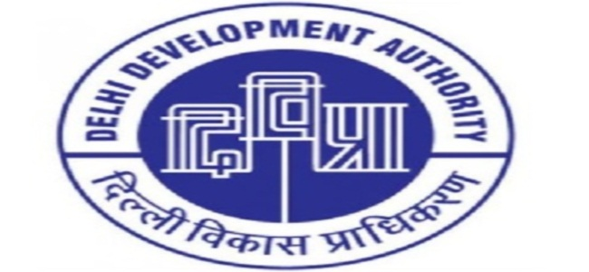
DELHI DEVELOPMENT AUTHORITY
DWARKA SPORTS COMPLEX

Attach coloured Passport Size photograph
NEW DELHI
MEMBERSHIP APPLICATION FORM
- Membership No.
(for office use only)

- Date of Membership
(for office use only)

- Type of Membership 1. General Category 2. Govt. Employee Category
- Name (in Block Letters)
- Father’s/ Husband’s Name
- Residential Address
PIN
- Office Address
PIN

- Mobile No.
(Mandatory)
- Email ID
(Mandatory)

- Occupation S-Service, B-Business, P-Profession, O-Others

- Details of Occupation

- Date of Birth

- Gender M-Male, F-Female, O- Any Other Category

- Marital Status S-Single, M-Married

- Nationality I-Indian, F-Foreign

- Educational Qualification 1. HSS, 2.Graduate, 3. Post Graduate, 4.Technical Graduate 5. Others

- Details of Dependants (including spouse)* who are to be enrolled.

Name
Attach Photo

Attach Photo

Attach Photo

Relation Date of Birth

Name

Relation Date of Birth

Name

Relation Date of Birth

Name
Attach Photo

Relation Date of Birth

- S-Son, D-Daughter, W-Wife, H-Husband
Note: - Document Required Prior Allotment of Membership.
- Residence/ ID Proof
- If Govt. Servant, Please attach the Employer Certificate, Photocopy of Identity Card.
- Age Certificate of Self, Spouse and Dependant members.
- One Photographs for each Member
- Spouse & Children between 5 to 21 years can be dependant members.
- Subscription fee is Rs. 150/- per month for the member and Rs. 70/- per month for each dependent member +18% GST from the date of approval of membership.

- I enclose here with Cash/Demand Draft No…………………….………..………dated …………….…………….….. drawn on …………………………………………………………………in favour of “CAU SPORTS, DDA” for an amount of Rs.118/- (Rs. One Hundred Eighteen Only) against the cost of application form.
(This is applicable when not paying by Debit / Credit Card)

- Undertaking
- All information furnished above are correct. However, my application form is liable to be rejected if details found to be incorrect.
- I have read the Rules and Regulation Bye-laws contained in the brochure of Dwarka Sports Complex and undertake to abide by the same.

Date………………………. (Signature of Applicant)
---------------------------------------------------------------------------------------------------------------------------------------------------------------------------

ACKNOWLEDGEMENT Application No.………………….
DELHI DEVELOPMENT AUTHORITY
DWARKA SPORTS COMPLEX, NEW DELHI

Received from Mr./Ms./Mrs……………………………………………………….application for the General/Govt. Servant membership of Dwarka Sports Complex and a Cash/Demand Draft No……………. dt………………drawn on………..…………………………………..for an amount of Rs.118/- (Rs. One Hundred Eighteen Only) or through Debit or Credit Card.

Date…………….. (Signature of the Receiving Clerk with Stamp)

GUIDELINES FOR OPENING OF PERMANENT MEMBERSHIP
FOR DWARKA SPORTS COMPLEX

- Application forms can be downloaded from home page and sports page of DDA’s website “www.dda.org.in”.
- Only one application should be submitted by an individual.
- Filled in downloaded application forms should be submitted at Admin Block Reception during working hours (10:00 a.m to 3.00 p.m) except lunch hours from 01:30 to 02:00 p.m at the complex.
- Membership form charges Rs. 118/- be deposited while submitting the form.
- Membership will be allotted through Computerized Draw. Intimation for holding of draw will be given on DDA’s website.
- After the final list of individuals whose membership has been approved will be displayed on the notice board.
- Successful Candidate will be required to deposit Entry Fee of Rs. 40,000 + GST for General Category and Rs. 15,000 + GST for Govt. Servant. Pay Order/Demand Draft should be drawn in favour of “CAU SPORTS DDA” Document Required to be submitted by the Successful Candidates:-
- Residence/ ID Proof
- If Govt. Servant, Please attach the Employer Certificate, Photocopy of Identity Card.
- Age Certificate of Self, Spouse and Dependant members.
- One Photographs for each Member
- Spouse & Children between 5 to 21 years can be dependant members.

